**PPL Lab 2**

Name: Aditi Paretkar

Roll: 1911034

1. Write a program to input principal amount, rate of interest , number of years from the user. Calculate and print Simple interest.

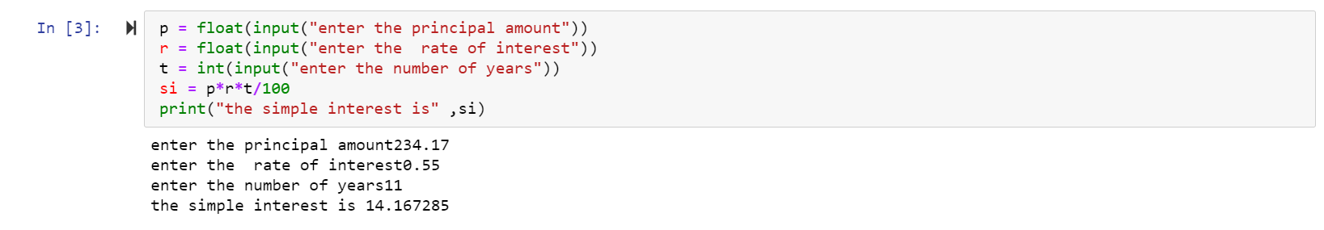

1. Write a program to convert temperature from degree Celsius to Fahrenheit

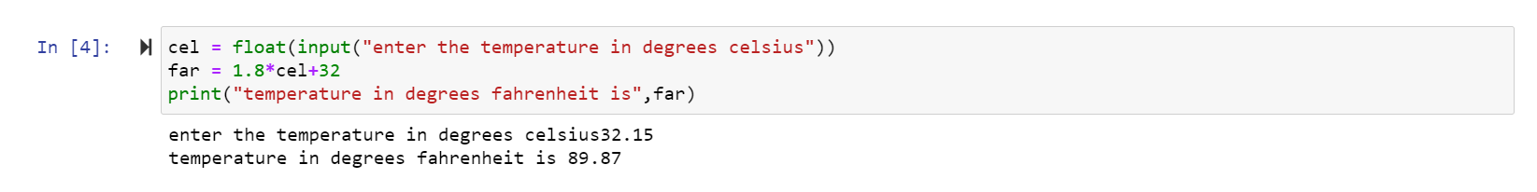

1. Write a program to calculate the area of an equilateral triangle where length of the side is entered by the user

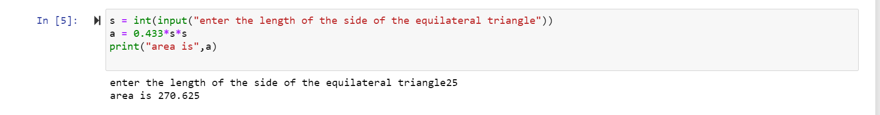

1. Write a program to convert days to years, weeks and days. Ignore leap year for the calculation

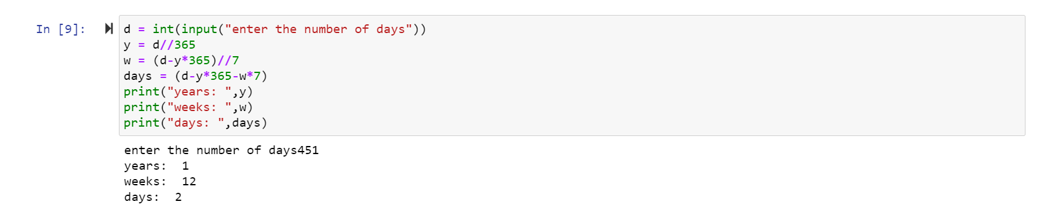

1. Write a program to swap two numbers.

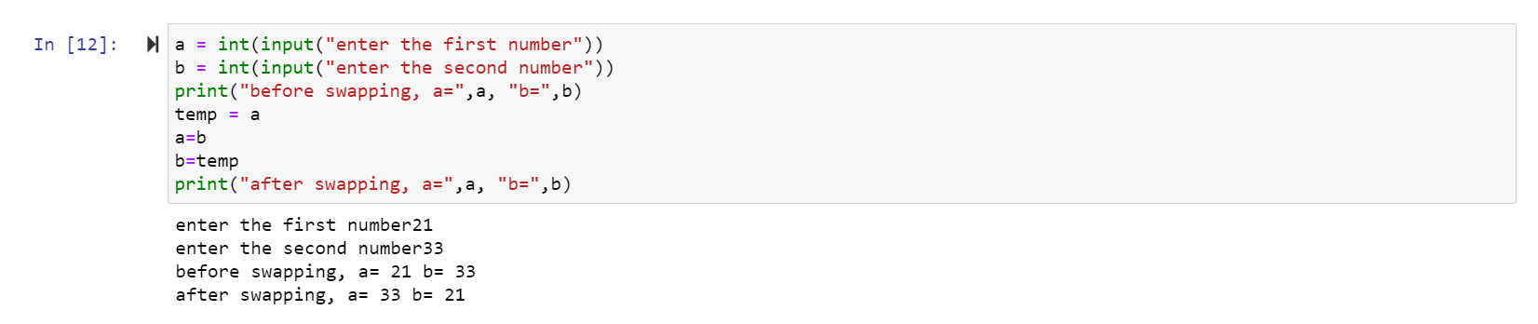

1. Read the Marks of five subjects out of 100 from the user. Write a program to calculate and print the aggregate marks, average and percentage.

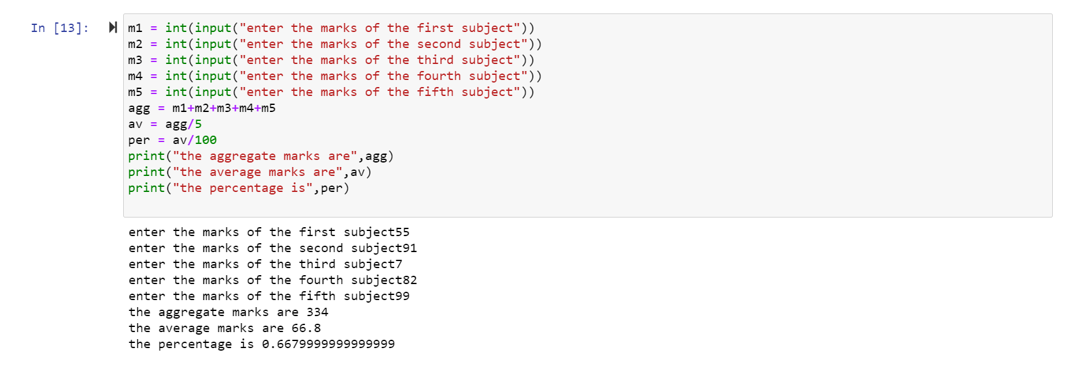

1. Write a program which requests a user to enter weight in kilograms. Convert it into pounds and print the result.

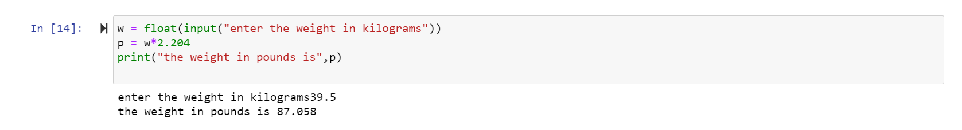

1. Ramesh’s Basic salary is input through the keyboard. His Dearness allowance is 40% of basic salary, House Rent Allowance is 20% of basic salary. Moreover the TA is 10% of Basic salary. Write a program to calculate his gross salary.

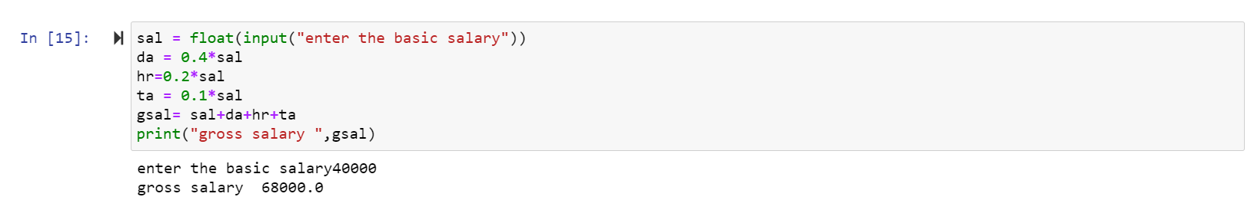

1. In a town, the percentage of men is 52. The percentage of total literacy is 48. If total percentage of literate men is 35 of the total population, write a program to find the total number of illiterate men and women if the population of the town is 80,000.

